Date | 26 June 2026
Team ID
Project Name | Sports Hall Booking System By Servicenow
Maximum Marks | 4 Marks

- Purpose of Document
The purpose of this document is to verify that the Sports Hall Booking System using ServiceNow meets the functional requirements and business objectives. User Acceptance Testing (UAT) confirms that students, faculty, staff, and administrators can successfully perform hall booking operations before the system is deployed.
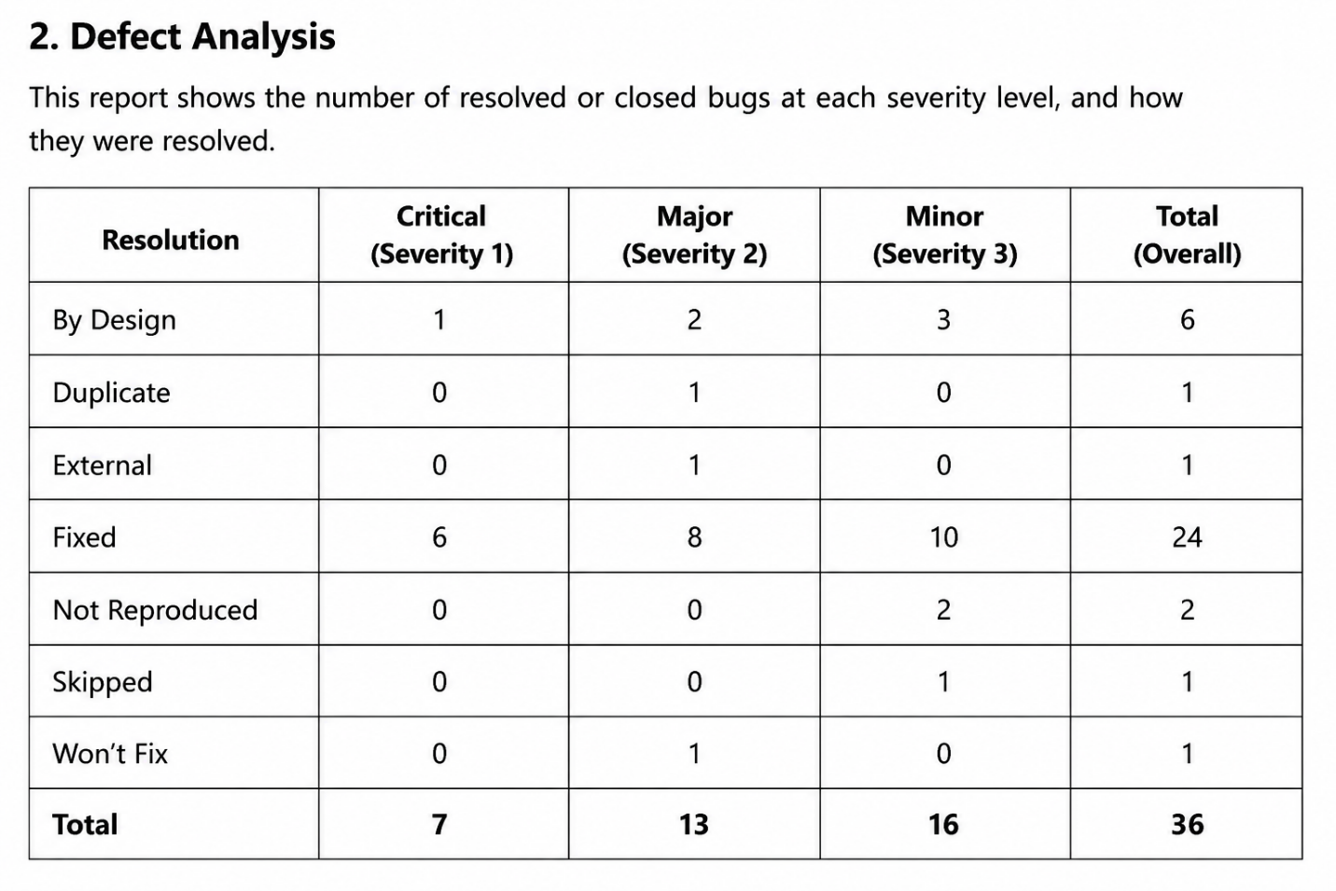

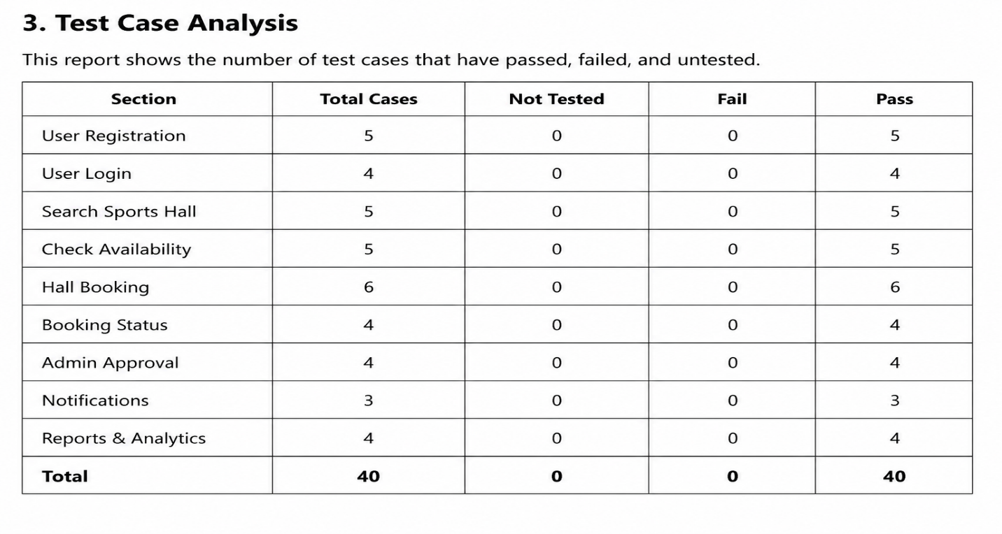
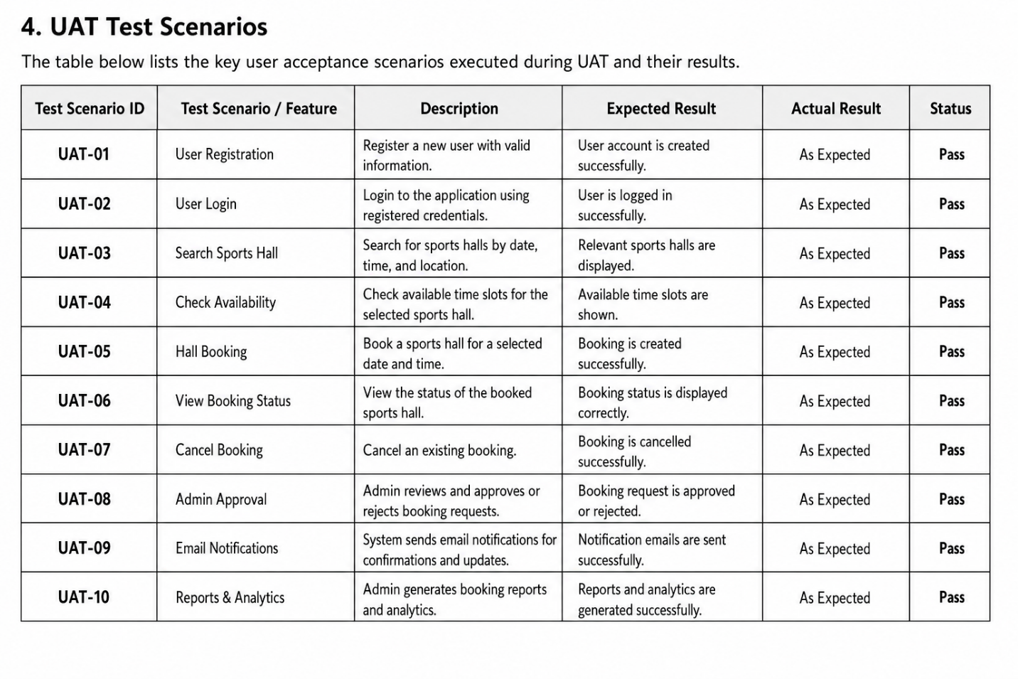
5. User Acceptance Summary
Total Test Cases: 40
Passed: 40
Failed: 0
Pass Percentage: 100%
Overall UAT Status: Accepted
6. Conclusion
The Sports Hall Booking System successfully passed User Acceptance Testing. All major features, including user registration, login, sports hall search, availability checking, booking, approval workflow, notifications, and reporting, worked as expected. The system is ready for deployment and use by students, faculty, staff, and administrators.

